/etc/fstab file corruption in CentOS 7 / RHEL 7

Create an issue
Become root
cat /etc/fstab (Check the entries)
vi /etc/fstab (Enter the wrong & save)
cat /etc/fstab (Check the wrong entries)
init 6

/etc/fstab file corruption then getting an error as shown in the image below

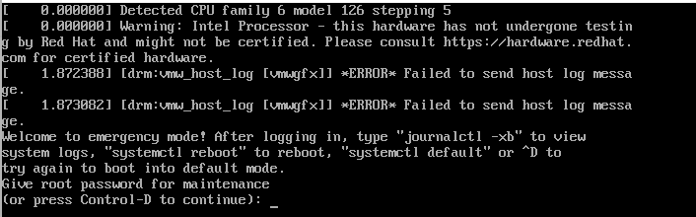

Give root password and Enter

cat /etc/fstab (Check the entries)
vi /etc/fstab (Correct the entries)
cat /etc/fstab (Check the corrected entries)
init 6

The system is started booting up without any issue

